**CONSULTIG LOGO**

**CLIENT LOGO**

**Initial Assessment:**

**Module**

**Date**

# **Document Control**

**Change Record**

| **Date** | **Author** | **Version** | **Change Reference** |
| --- | --- | --- | --- |
|  |  |  |  |
|  |  | 1 | Initial Version |
|  |  |  |  |
|  |  |  |  |
|  |  |  |  |
|  |  |  |  |
|  |  |  |  |

**Approvers**

| **Name** | **Position** | **Signature/Date** |
| --- | --- | --- |
|  |  | |
|  |  |  |
|  |  |  |
|  |  |  |
|  |  |  |
|  |  |  |
|  |  |  |

# **Summary**

**Document Control** 2

**Summary** 3

**Purpose** 4

**Module - Initial Assessment Questions** 5

**Module - Flow** 7

**Open and Close Issues** 8

**Open Issues** 8

**Closed Issues** 8

# **Purpose**

This document aims to gather comprehensive insights about the [Module Name] module through a set of carefully crafted questions. These responses will support the initial configuration of the module and highlight any potential matches or differences with its built-in features.

* The questions target the core operational processes within the [Module Name] module, emphasizing essential aspects tied to its primary functions. That said, they do not address needs for tailored adjustments, system connections, or data transitions.
* This effort plays a vital role in identifying nonfunctional needs, design boundaries, and other key considerations critical to fully grasping the software’s requirements.

Please keep in mind that these questions might not capture every distinct process unique to your organization. For this reason, we invite you to include any additional relevant information in the sections reserved for use cases and practical examples.

# **Module - Initial Assessment Questions**

**### Generic Questions for Understanding Current Module Operations**

To gain a comprehensive understanding of how the client currently operates within the [Module Name] module, please consider the following questions:

**1. Roles and Responsibilities**

- Who has access to the [Module Name] module?

- What are the roles and responsibilities of users interacting with this module?

- Are there specific permissions or restrictions based on user roles?

**2. Master Data and Registration**

- Does the [Module Name] module manage any type of registration or master data (e.g., customer records, vendor details, product catalogs)?

- If yes, please provide details about the types of data managed, how it is maintained, and any associated processes or workflows.

**3. Transaction Types**

- What types of transactions are created and executed in the [Module Name] module?

- Can you provide examples of these transactions?

**4. Frequency**

- With what frequency are these transactions created (e.g., daily, weekly, monthly)?

- Are there peak periods when transaction volume increases?

**5. Workflow**

- Can you describe the step-by-step process for a typical transaction in the [Module Name] module?

- Are there any automated steps in the workflow, or is it entirely manual?

- Are there approval processes involved? If so, please describe them.

**6. Data Sources and Integration**

- What are the main sources of data for transactions in the [Module Name] module?

- Does the module integrate with other systems or modules? If so, which ones?

- Is the integration for receiving information, sending information, or both?

- Can you describe the flow of information between the [Module Name] module and other systems?

**7. Reporting**

- What types of reports are generated from the [Module Name] module?

- How are these reports used in your business processes?

- Are there specific reporting requirements or challenges?

**8. Pain Points**

- What are the main challenges or inefficiencies you experience with the current processes in the [Module Name] module?

- Are there specific areas where you would like to see improvements?

**9. Compliance and Audit**

- Are there any compliance or regulatory requirements that the [Module Name] module must meet?

- How are audit and monitoring managed within the module?

**10. Scalability and Performance**

- How does the [Module Name] module perform with current transaction volumes?

- Are there concerns about scalability as the business grows?

# **Module - Flow**

This section is dedicated to providing a graphical representation of the module and its integrations, designed to enhance your understanding of the system's architecture and interactions. Through these visual illustrations, we aim to simplify the complexity of the module's connections, making it easier for you to grasp how different components work together. These diagrams not only clarify intricate details but also serve as a valuable reference during discussions or when analyzing the system's functionality. We encourage you to explore these graphics to gain a clearer insight into the module's role and its integration points within the broader system.

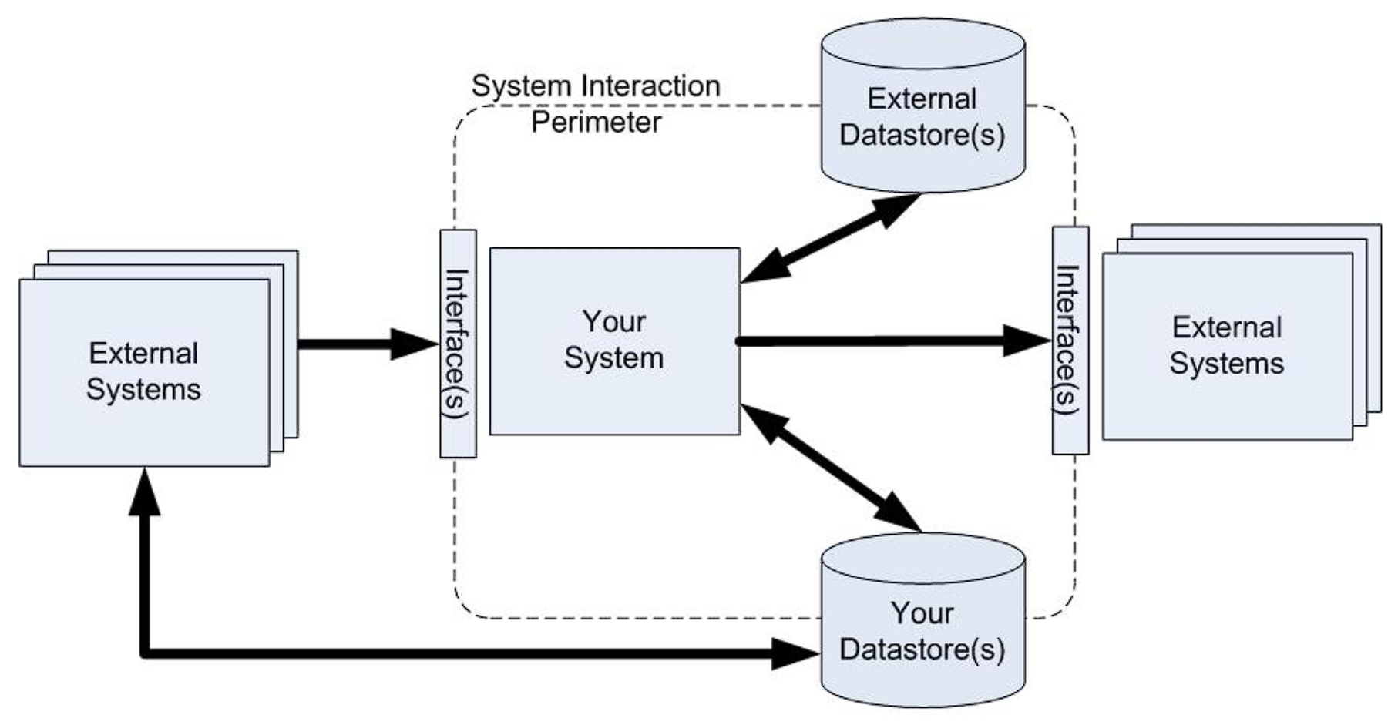

# **Open and Close Issues**

## **Open Issues**

| ID | Question | Resolution | Responsible | Target Date | Impact Date |
| --- | --- | --- | --- | --- | --- |
|  |  |  |  |  |  |
|  |  |  |  |  |  |
|  |  |  |  |  |  |
|  |  |  |  |  |  |

## **Closed Issues**

| ID | Question | Resolution | Responsible | Target Date | Impact Date |
| --- | --- | --- | --- | --- | --- |
|  |  |  |  |  |  |
|  |  |  |  |  |  |
|  |  |  |  |  |  |
|  |  |  |  |  |  |